Riders per quarter

Q4 and Q3 boasts the highest number of rides in both customer segments. Naturally, Q2 and Q1 fall behind in numbers with affecting factors likely to be cold weather. It is evident that customer consumption is seen high in summer months rather than winter months and this behaviour is identical in both casual and members.

Rides by Month

When compared statistics of monthly rides by membership type, a similar trend in customer behaviour is seen in both customers. The number of rides grow rapidly during transition from spring to summer and fall sharply during the winter months. Members in general exhibit higher numbers than casual riders and this trend in maintained throughout the calendar year.

As seen in the set of bar graphs above, casual riders seem to be most active during weekends while the numbers shrink in the weekdays. Conversely, members tend to use the bikes consistently throughout the week followed by sharp decline in the weekends. Peak rides in casual riders can be seen on Saturday with Sunday as the second highest performing day. Whereas Tuesday, Wednesday and Thursday seem to be popular preferences for members and exhibit identical ride statistics. This comparison suggests that members are predominantly using the bikes for commuting to work while casual riders do it for recreational purposes.

In terms of time preferences, both casual and member riders show peak numbers at 5 pm. The line graph shows number of casual rides rise gradually from 5 am until its peak at 5 pm and then followed by sharp fall. On the other hand, member rides follow an irregular trend where numbers increase rapidly from 6 am to 8 am and fall after that. The rides increase rapidly from 3pm to 5pm. This further confirms that member are using the bikes for commute.

Overall, casual riders exhibit higher average ride time than members. The average ride time for casual riders nearly doubles in the weekend and declines during the weekdays. Meanwhile, members’ average ride length for the most part stays consistent throughout the week with a slight increase in the weekend.

Average ride length is seen highest during the mid-day for casual riders and lowest in the early hours. Meanwhile, average ride length stays consistent between 10 to 12 minutes.

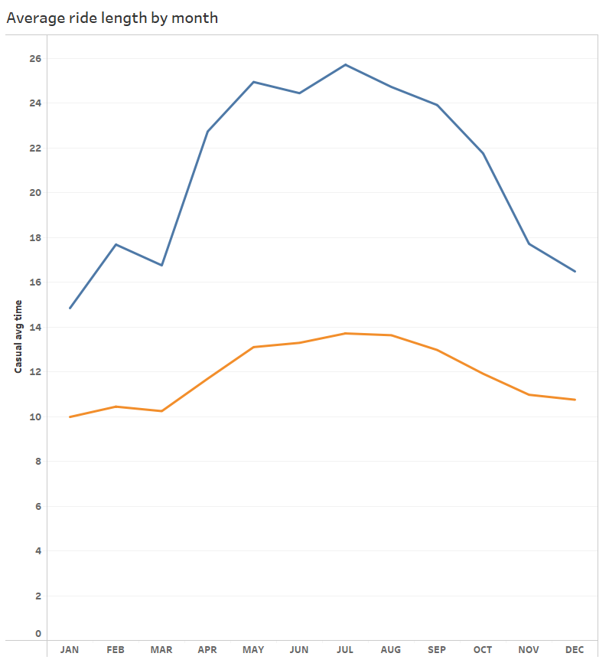

When average ride of is compared it is discovered that the length of trips is highest in the spring and summer months and fall after for both type of customers. Average ride length by casual riders is nearly double the length of trips by members.

The graph above shows similar trend for both type of riders where average ride length is highest on the weekend. The rise in ride length is steeper in casual riders than members.

The top stations map reveals most members started their rides in the vicinity of universities, hospitals, local parks, restaurants, train stations, office blocks and water bodies. Whereas casual riders frequented rides starting from beaches, piers, museums, and large parks. This directly correlates to the aforementioned findings leading to a confirmation that casual riders use the bikes for recreational purposes while members may use it for commute or to support their lifestyle.